**NAME: M.ASIF**

**REGNO: BSE233078**

**SECTION:02**

**LAB:06**

**SUBMITTED to:** **MAAM FARYAL HAYAT**

1. **Insert a new job with the following information a. Job id is “P_PROG” b. Job title is “Python Programmer” c. Min Salary is 60000 d. Max Salary is 100000.**

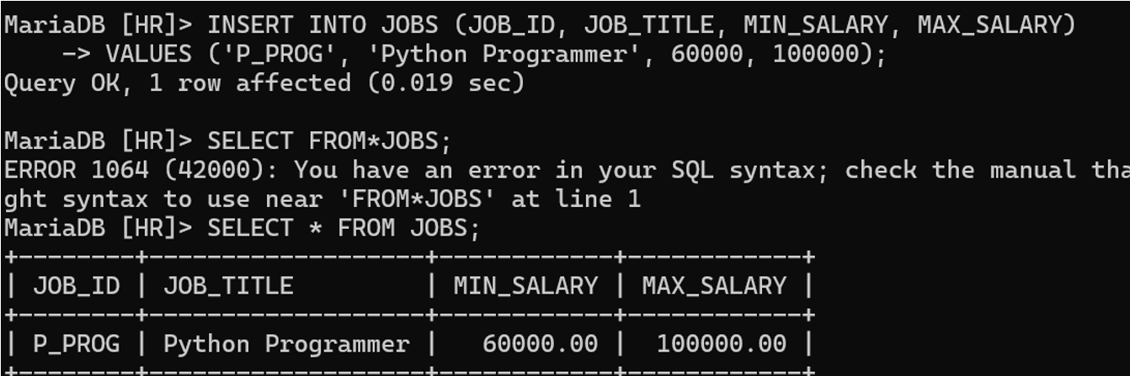

1. 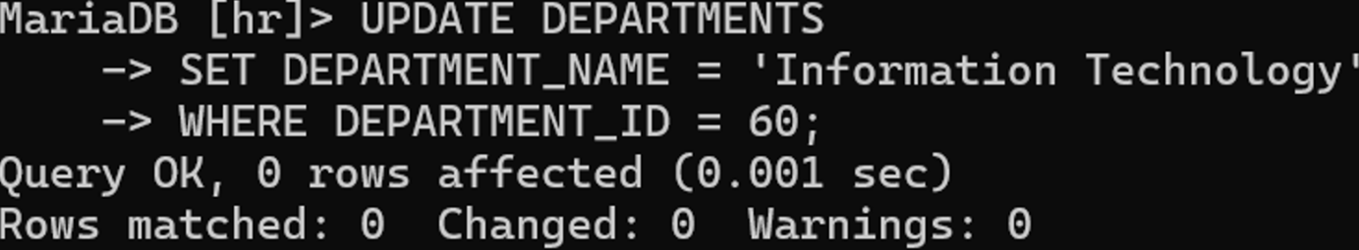**Update the name of Department whose department_id is 60, the new name is Information Technology.**
2. **Update the minimum and maximum salary of the above inserted record, the new Minimum salary is 20,000 and max salary is 40,000.**

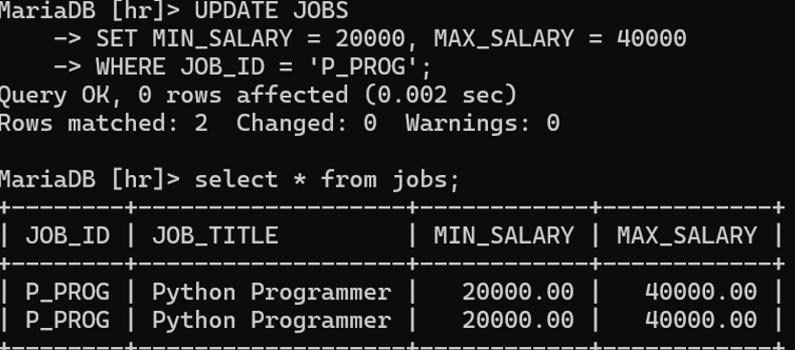

1. **Add 5000 to maximum salary of all jobs whose id is FI_MGR.**

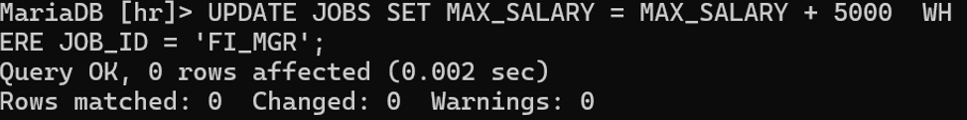

1. **Delete the inserted new record of location table.**

DELETE FROM LOCATIONS

WHERE LOCATION_ID = NEW_LOCATION_ID;

1. **Select all the records of Countries table.**

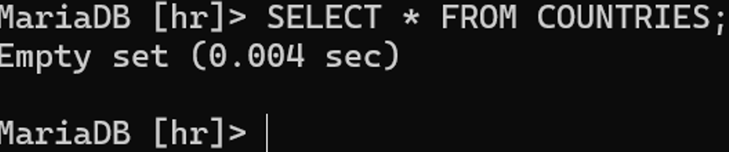

1. **Select all the records of job_history table.**

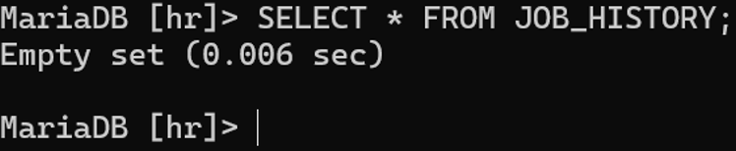

1. **Select all the records of regions table.**

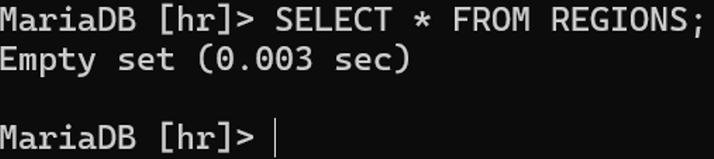

1. **Select location_id and streetaddress of location table.**

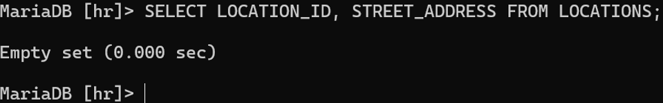

1. **Show all employees whose job_id is IT_PROG**

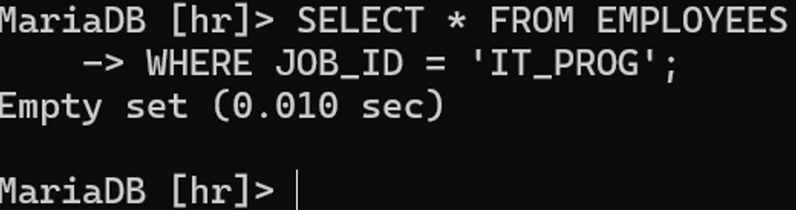

**11. Show all location information including location_id, street_address etc of US country.**

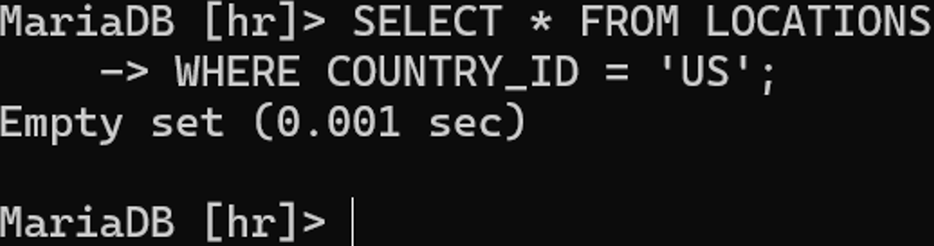

**12 . Show first_name, last_name, email of employee whose job_id is FI_MGR.**

